Networks Devices

What Are Networks Devices?

# Source: Chatgpt (GPT‑5 Mini) at [12/18/2025]
Network devices (also called networking hardware) are the physical devices that connect computers, smartphones, servers, and other devices to a network — whether it's a local area network (LAN), wide area network (WAN), or the internet.

🔌 Common Network Devices
# Source: Chatgpt (GPT‑5 Mini) at [12/18/2025]
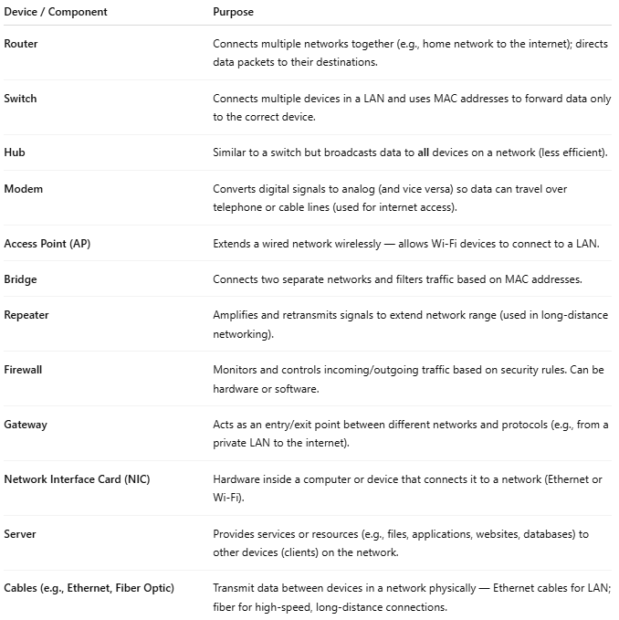

Device / Component | Purpose
Router | Connects multiple networks together (e.g., home network to the internet); directs data packets to their destinations.
Switch | Connects multiple devices in a LAN and uses MAC addresses to forward data only to the correct device.
Hub | Similar to a switch but broadcasts data to all devices on a network (less efficient).
Modem | Converts digital signals to analog (and vice versa) so data can travel over telephone or cable lines (used for internet access).
Access Point (AP) | Extends a wired network wirelessly — allows Wi-Fi devices to connect to a LAN.
Bridge | Connects two separate networks and filters traffic based on MAC addresses.
Repeater | Amplifies and retransmits signals to extend network range (used in long-distance networking).
Firewall | Monitors and controls incoming/outgoing traffic based on security rules. Can be hardware or software.
Gateway | Acts as an entry/exit point between different networks and protocols (e.g., from a private LAN to the internet).
Network Interface Card (NIC) | Hardware inside a computer or device that connects it to a network (Ethernet or Wi-Fi).
Server | Provides services or resources (e.g., files, applications, websites, databases) to other devices (clients) on the network.
Cables (e.g., Ethernet, Fiber Optic) | Transmit data between devices in a network physically — Ethernet cables for LAN; fiber for high-speed, long-distance connections.

Types Of Devices photo
# Source: Multi sources: Types Of Devices -> at - (Top)
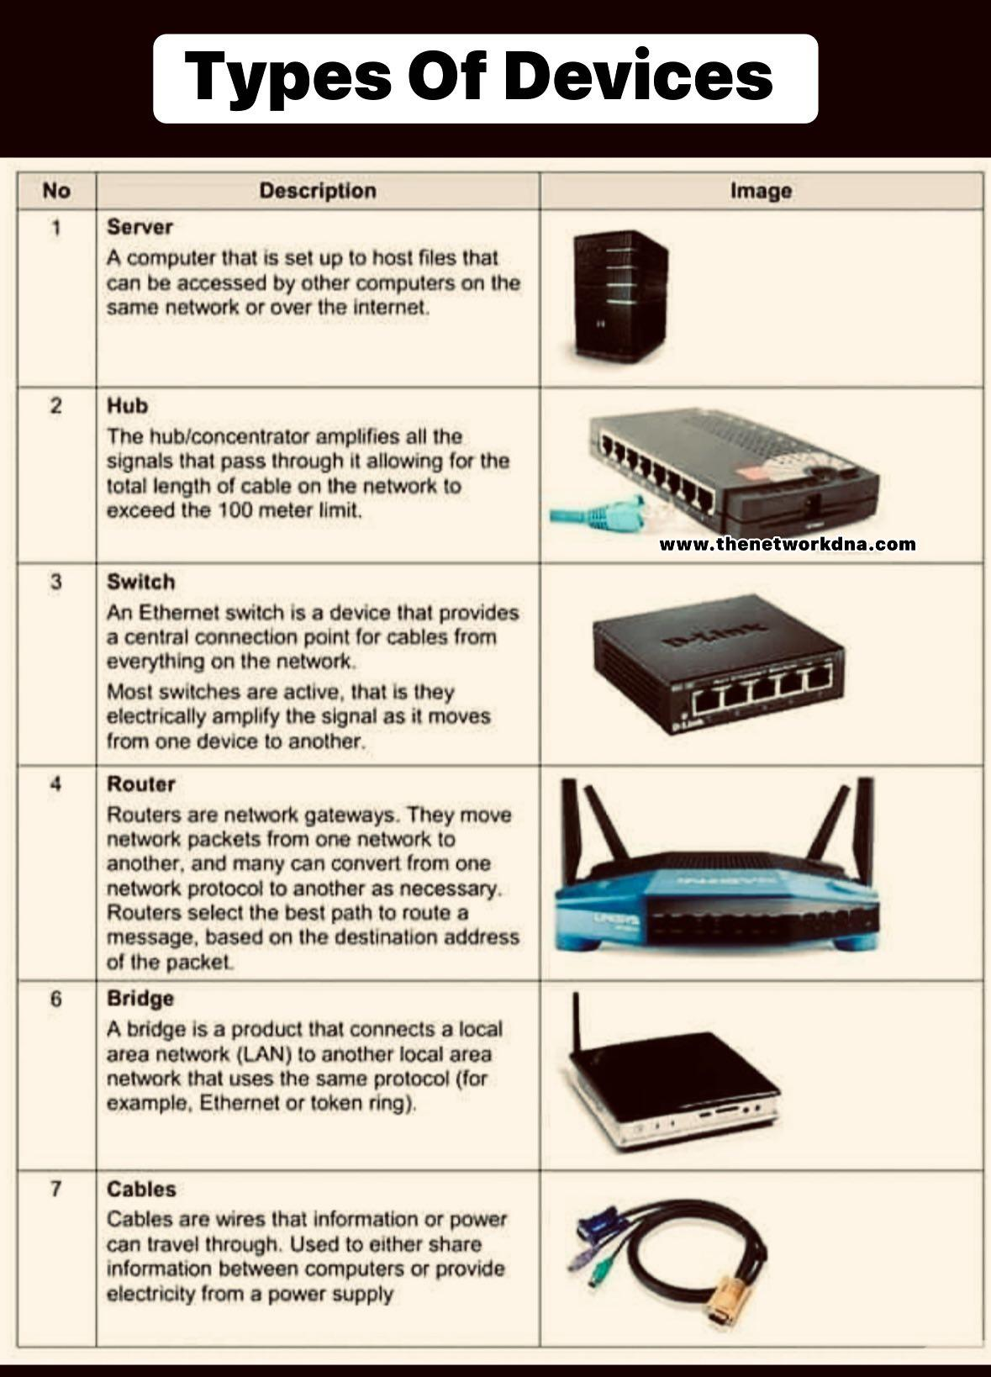

🏠 Example in a Home Network
# Source: Chatgpt (GPT‑5 Mini) at [12/18/2025]
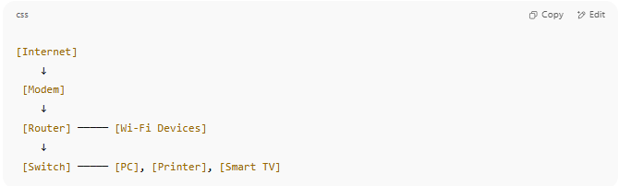

[Internet]
↓
[Modem]
↓
[Router] ───── [Wi-Fi Devices]
↓
[Switch] ───── [PC], [Printer], [Smart TV]

